FAQs about the West Africa drought and hunger crisis

Quick facts and figures:
- An estimated 18 million people are in need of assistance across West Africa. This includes: Niger 6.4 million; Mali 3.5 million; Burkina Faso 2.85 million; Chad 3.6 million; Senegal 800,000 thousand; Mauritania: 700,000 thousand
- 1 million children suffering from Severe Acute Malnutrition
- 3 million children suffering from moderate malnutrition
- There 4 million children are at risk
- World Vision is appealing for $60,000,000 to help more than 1.1million of most vulnerable in five affected countries
- 645,000 children die in Sahel each year; 35% linked to malnutrition

Q What is the extent of the crisis in West Africa?
It is estimated that around 18 million people are in need of assistance across West Africa; with 6.4 million people estimated to be at risk in Niger alone. A combination of drought, lack of food, the communities being easily affected due to recent food shortages and the next harvest scarily being months away mean that millions of people across Niger and the Sahel are at risk.
Most disturbingly for us, nearly 4 million children under the age of 5 across the region are affected. West Africa is the world’s poorest region, and we are concerned about those who are most vulnerable — pregnant women and children — in the most-affected countries.

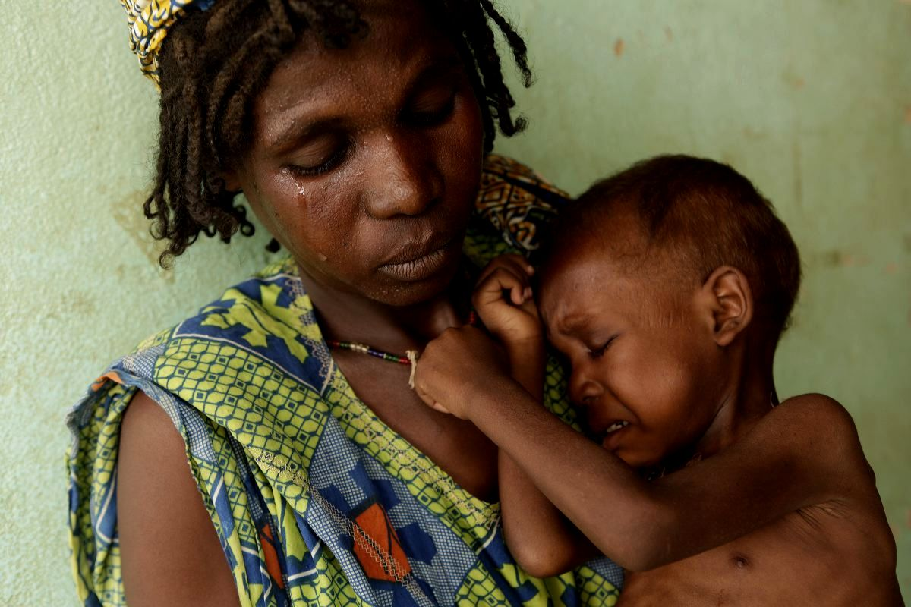
Fatimata and 2-year-old son Soumaila. Photo Mike Goldwater.

Q: What went wrong?
A deadly combination of low rainfall and rising food prices have led to poor harvests and declining food supplies. Food from crops have been nonexistent in some areas and severely reduced in others.
As communities enter the lean period – the traditional time each year when food stocks are low - their food reserves are at a minimum. Some people may be forced to eat seeds now that were meant to be planted for crops next year.

While there has been some food in the local markets despite shortages, the price is incredibly high.

There has also been recent conflicts, the return of hundreds of migrant workers, and a flow of refugees from Mali into one of the most affected areas of Niger further strained an already stressed food supply.

Q: When are the rains likely to return?
The next rains are due in July. Even if there is good rainfall in July, there will be no harvest until October.

Q: What is the impact on children?
- One coping strategy that communities use in (such as in Niger, Mali, Mauritania) is to force a family member to leave, mostly girl children, to towns and cities so that they can find jobs as maids and support their families back home with money.
- As a consequence of the lack of rain, water points have dried out, forcing children and women to travel for longer distances to fetch water, making them vulnerable to potential attacks from human and animals.
- West Africa (particularly Mali and Niger) has high rates of early marriages; there are fears that food shortages can be a factor in girls being married as young as seven.
- Potential school drop outs as parents move to other locations in search for work. This has already been observed in Mauritania, and teachers and parents have warned about this risk in Niger.
- Children having to go to school hungry, not being able to concentrate and generally being more vulnerable to falling sick.

Q: How is World Vision helping?
World Vision has programs in Niger, Mauritania, Senegal, Mali, and Chad, designed to immediate needs and improve long-term food security.
To meet the needs of more than 1 million people in the region, our activities to help include:
> Nutrition programs for children
> Food distributions
> Vaccinating livestock
> Distributing seeds
> Drilling additional wells
> Educating parents to help them keep their children healthy
> Restocking cereal banks
> Providing additional livestock
World Vision is also actively advocating for national governments, regional organizations, the United Nations, and the international community to act immediately to prevent this crisis from happening again.

Q: What are the consequences if nothing is done?
The consequences are likely to be an extended period of hunger and malnutrition, not enough seeds for a new crop next year, families relocating from rural to urban areas, death of vital livestock, incredibly high food prices, and a diminished ability for communities to feed themselves in the future.
And, of course, the most terrible consequence of extended drought and lack of food is loss of life.

Q: How long has World Vision been working in West Africa?
World Vision started working in West Africa in 1973 by providing much-needed emergency relief support to drought affected Niger, and continued by establishing water, agriculture and literacy projects in Mali in 1975. To date, World Vision works in seven countries across West Africa (Chad, Ghana, Mauritania, Mali, Niger, Senegal, Sierra Leone), providing a range of long-term development, advocacy and emergency relief initiatives. These efforts have resulted in providing a better life for 367,373 registered children (as of 31 Oct 11) and their communities in our region.

Q: What is World Vision’s partnership with the British Government?
The British Government are matching our #ShareNiger appeal fundraising pound for pound, helping us reach thousands more people as a result. The money raised will help to deliver emergency food aid, water and agricultural support to children and families at risk. It will also help communities’ long term ability to avoid future disasters, by developing food reserves where they can collect food for their family and provide seeds that can be planted for crops for next year.
If you are inspired to write about the appeal, please make sure to let your readers know their donations will be doubled. This matched funding covers all West Africa food crisis appeal donations received over the next three months (30TH May – 30th August) when the need for response will be at the most critical stage.
*Please note, it does not include ongoing donations such as Child Sponsorship of monthly regular giving, so bear this in mind if encouraging your readers to sponsor a child.
You could also help by spreading the word of the British Government’s match funding, telling your friends and family of the benefits of donating to our West Africa appeal – every pound donated is a pound matched. Every little bit helps.

Q: What are the way you can help?
#ShareNiger.
Please help us to #ShareNiger and spread the stories of those at the heart of the food crisis. We need urgently to raise awareness of the food crisis and to give a voice to the children currently affected.
Be creative. Use twitter, your blog, facebook, instagram, youTube. You could also take it offline – by telling your school, church, parenting group, your children, family and friends. Together we can spread awareness across the world, one story at a time.
We’ve attached logos if you are interested in using them for your story telling.
Make a one-donation to our West Africa food crisis appeal.
By making a life saving donation to the West Africa food crisis appeal you can help provide life-saving treatment for a malnourished child, ensure hygiene and sanitation kits reach families and provide vital health consultation and treatment. Remember that until 30 August, the British Government will double your donation to this appeal.
Give monthly by sponsoring a child to provide long term assistance for children experiencing hunger.
Your monthly contribution will help provide critical interventions like emergency food aid, agricultural assistance, clean water, and more to those in greatest need. This will change the life of a child.

